Project Report 

|  |  |
| --- | --- |
| **Product Name** | Applied Degree in Software Engineering (BDSE) |
| **Qualification Name** | Applied Degree in Software Engineering |
| **Product Name** | Programming Foundations |
| **Module Name (BDSE)** | **Programming Foundations** |

|  |  |  |  |  |
| --- | --- | --- | --- | --- |
| Learner name | | | Assessor name | |
| Syukur Sidiq Nur Alam | | |  | |
| **Date issued** | **Completion date** | | | **Submitted on** |
| 25-11-2022 | 25-11-2022 | | | 25-11-2022 |
|  | | | | |
| **Project title** | | **Development of MCQ System** | | |

### Plagiarism

Plagiarism covers both copying or paraphrasing with the source without proper understanding and citation. The source includes but is not limited to

* Books, Journal Articles, Online resources
* Others Assignment or project
* Software program
* Images

The learners must submit their work without plagiarism while producing the evidence against the assessment criteria. They must apply proper citation and Harvard referencing. Their work must go through the Turnitin software to check for the similarity index. Please consult the relevant module instructor or mentor if you need any further advice.

|  |
| --- |
| **Learner declaration** |
| I certify that the work submitted for this assignment is my own and research sources are fully acknowledged.  Student signature: Date: |
|  |

Lithan | EDU Class © 2022

Table of Contents

1. Introduction

2. Background

3. Task 1:

Briefly describe what an algorithm is and design an algorithm to process the form inputs and outputs of the process in the project scenario.

4. Task 2:

Explain briefly Procedural, Object Oriented and Event driven paradigms, Give example of programming language which will be used to implement each of them.

What programming paradigms you use for this project ?

Document the architecture of the System along with Module and its Components description.

5. Task 3:

Provide the source code of implementation for the algorithm written in Task 1.

Provide a brief note on how the algorithm is translated to equivalent code.

6. Task 4:

Briefly explain how you have used object oriented features to build the application. 14

Provide sample source code and explain how you have used object oriented features to create a particular functionality.

7. Task 5:

List and briefly explain the steps you will follow from writing code to execution.

8. Task 6:

Explain briefly 5 features which are available in IntelliJ or Eclipse, which you use to build this application.

9. Task 7:

Explain briefly how using an IDE is better than not using an IDE.

10. Task 10:

Explain briefly the steps involved in debugging and how does it helps to develop more secure and robust applications.

### Development of MCQ System

# Introduction

# My Summative Assessment for the "Applied Degree in Software Engineering" Course's "Foundations of Programming" Module. The Writer will use Java to design, implement, and test an MCQ system for this project. The Writer has the chance to showcase writer abilities in the following areas through this project:

# 1. Capable of creating Java command-line apps.

# 2. Outline the web application programming process and define the fundamental algorithms for database operations.

# 3. Prove your programming expertise in procedural, object-oriented, and event-driven design.

# 4. Developing the application with, IntelliJ, or Eclipse.

# 5. Describe the debugging process and discuss the significance of coding standards.

# 6. Construct technical documentation and run unit tests.

# Background

# Scenario

# The Writer is working as an intern for a significant education industry leader. They extended into the study of information technology as a part of their development. The Writer currently works on a team that develops software to evaluate subject expertise. The following situations are provided, and the company is required to submit the MCQ system:

# 1. The system must handle multiple sets of multiple-choice questions. For instance, Basic HTML, Control Structures, and Java.

# 2. The system will display questions from the selected list when you choose a set.

# 3. Allow people to respond, and score them depending on their responses. For instance, if a user correctly answers 8 out of 10 questions, they should receive a score of 80%.

# As a member of the research and development team, The Writer's responsibilities include looking into new procedures that might be advantageous to the business. The Writer was requested to conduct research to identify an appropriate algorithm. The Writer must describe an algorithm, give usage examples, evaluate its effectiveness compared to brute force techniques, and explain how it links to the application development process and language implementation. The Writer must explain how to debug the developed software in the second section, as well as how the tools built within the IDE work to make this process easier. Use a real-world example from the program's debugging to demonstrate this idea. To make sure that the program is reliable and safe, the Writer needs to study the debugging process and give an evaluation of how it may be applied.

# Task 1

#### An algorithm is a limited number of discrete, step-by-step instructions to solve a problem. In programming activities, an algorithm is typically viewed as a logic to decide the program to be made. However, another definition of an algorithm is a path utilized in a calculation or systematically addressing a problem.

#### 

* MCQ System Development Pseudo Code:

1. INPUT NAME

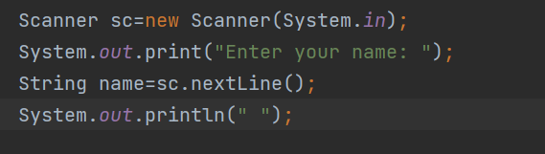

1. File Reader

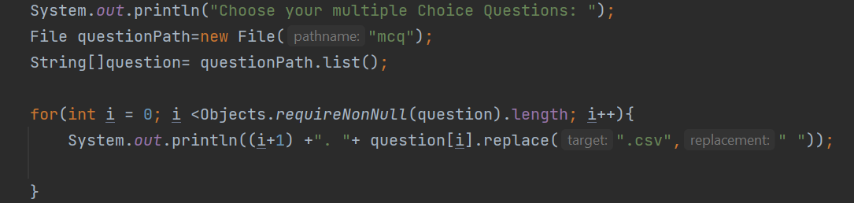

1. String Array

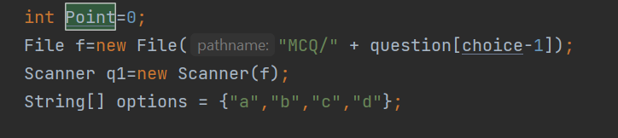

1. Answer

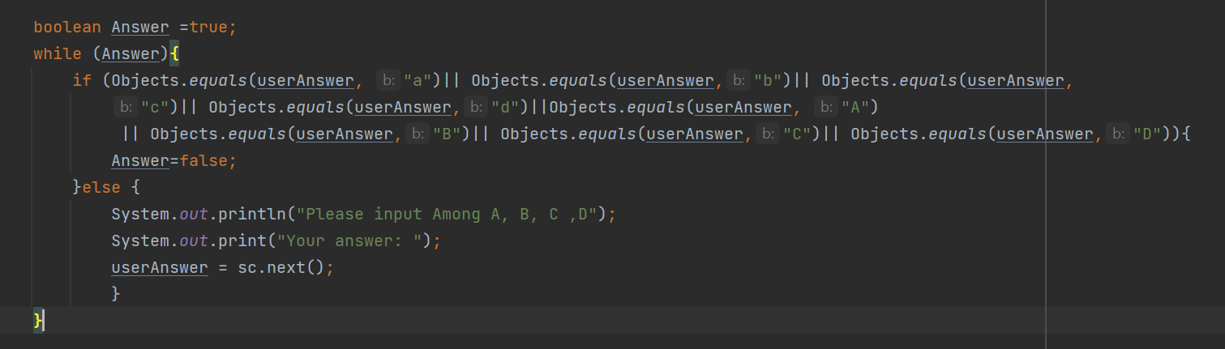

1. Result

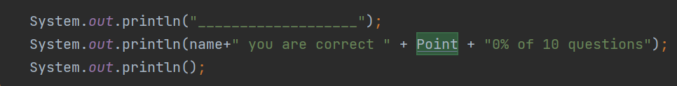

* MCQ System Development Algorithm:

1. The program starts.
2. Ask the name of the student.
3. Get access to the CSV file using java.
4. Reading files using java.
5. Display questions to students
6. Input answers from students for each question.
7. Calculate the score based on the correct answers from students.
8. Displays the names and Score of students.

# Task 2

# OOP

#### According to Gillis and Lewis, Object-oriented programming or OOP is defined as object-oriented programming which is a computer programming model with software design settings around data or objects. Unlike another programming that focuses on function and logic, OOP focuses more on objects or data fields that have unique technical attributes or behaviors. OOP's focus on objects allows for developer manipulation and lends itself well to large, complex programming. This OOP approach is easier when it comes to updates and maintenance.

#### OOP can be used in various programming languages such as JavaScript, C++, Java, and Python. The use of this class in OOP programming can determine what attributes an object instance will have, such as color and so on. OOP is becoming more concise because developers can focus more on manipulating objects than logic or functions.

# Procedural Paradigm

is a programming paradigm derived from structured programming and based on the concept of procedure calling. Procedural programming, also known as "routines," "subroutines," or "functions," simply contains a set of computational steps that must be performed.

# Object Oriented Programming

Programming paradigm known as object-oriented programming (OOP) is based on the idea of objects, which are collections of data stored in fields, and code, which denotes operations, as opposed to the typical logic-based system.

**Event Driven Programming Paradigm**

# An event-driven system, as defined by Berson (1992), is a collection of objects that communicate with one another via messages. A different element, commonly referred to as the event dispatcher, is in charge of managing this process.

**Example of Programming Language Which Will Be Used in The Implementation and The Programming Paradigm**

# The Writer will be used Java Language Program to design The MCQ Test.

# Object Oriented Program (OOP)

# Because the writer produced an object with a state that can only be changed by built-in procedures—in this case, a Student class—the writer employed the object-oriented programming paradigm.

1. The Functional Programming paradigm

# The Writer has been using the functional programming paradigm because The Writer created a calculation that calculates the results of a test that students/examinees will take.

# Task 3

#### MCQ Test Development Algorithm :

1. The program starts.
2. Ask the name of the student.
3. Get access to the CSV file using java.
4. Reading files using java.
5. student choose what MCQ they want.
6. Display questions to students.
7. Asking for input as answers from students for each question.
8. Calculate the score based on the correct answers from students.
9. Displays the names and grades of students.

|  |  |
| --- | --- |
| Note | Screen Capture |
| Start The Program |  |
| Asking student’s name |  |
| Get access to the csv file using java. |  |
| Reading files using java & display questions to students |  |
| Asking for input as answers from students for each question. |  |
| Calculate the grade based on the proper answers, and if any students gave incorrect ones, show them the right response. |  |
| Displays the names and grades of students. |  |

# Task 4

The OOP concepts used by the Author to implement the program:

The author created an Opening class to display attributes in the Main class,

the user each time their test has to choose the correct answer, this uses the Choice attribute of opening class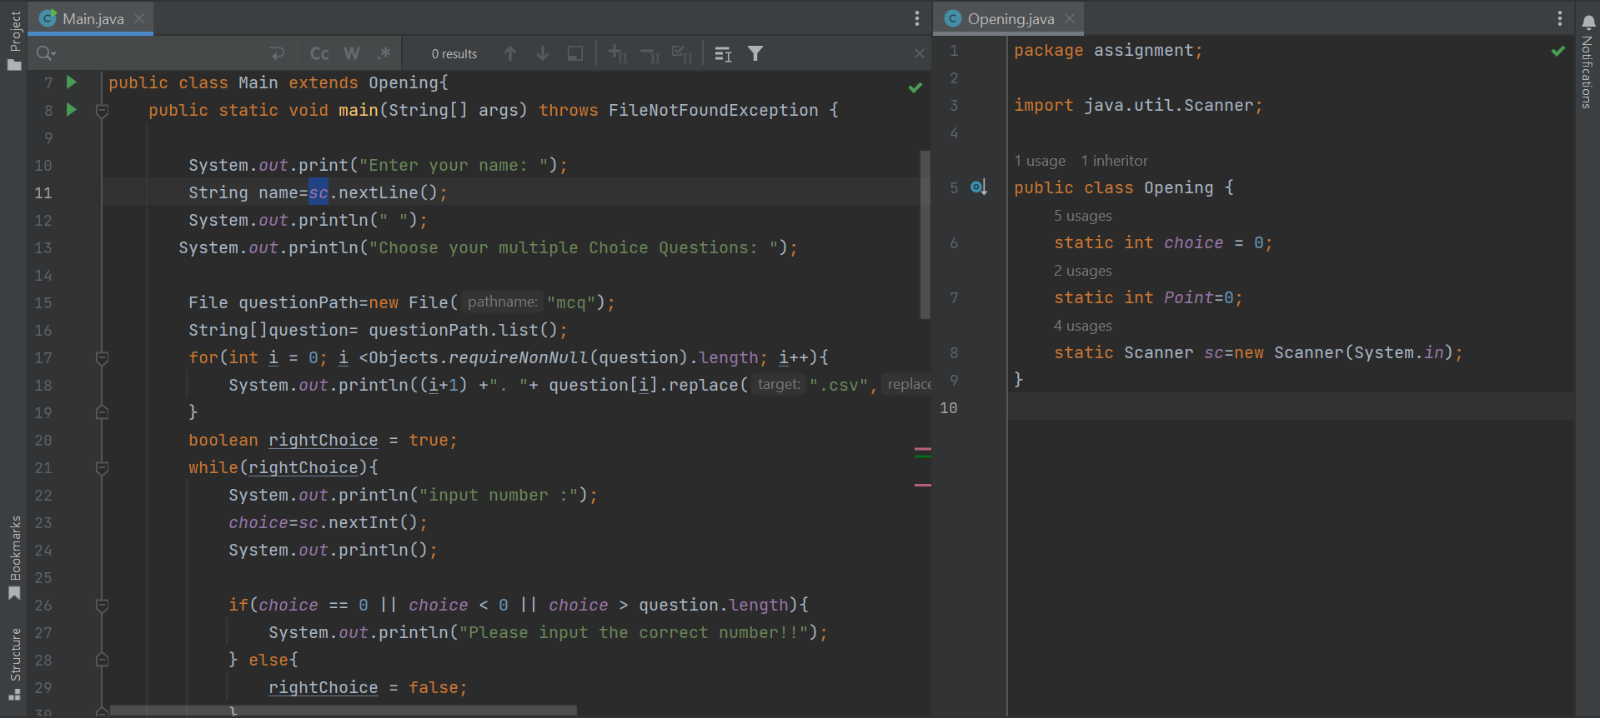

When students are working on a test, their total score will be displayed using the Point attribute of opening class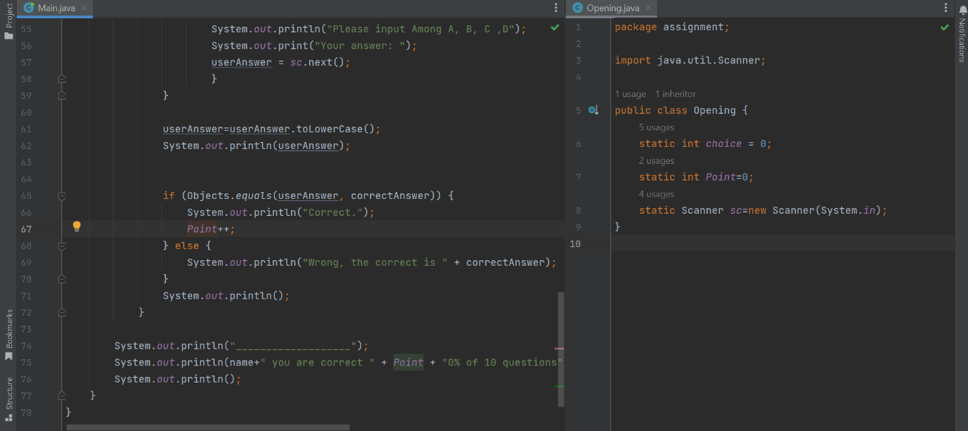



# Task 5

Step by step that I follow to create this MCQ program:

1. Create a CSV file that will store the MCQ questions on Microsoft Excell, Google Spread Sheet.
2. Create a folder as a place to store CSV files. This folder willl contain all the set of MCQ Test.

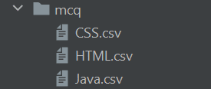

1. Create a new java class called “mcq.java”. This class will perform some of the following tasks:

* Read the CSV file
* Store it in an array
* Print it by starting with the question first and then the options of answer
* Ask for input from students as an answers to the questions and check whether the answers are right or wrong.
* Show Score Result and Name of Student

# Task 6

#### 5 characteristics that The Writer used to create this program:

1. Easy Setup, user can create a new Java file easily

#### 2. Deep code analysis

#### It helped The Writer with the code while The Writer was working on this project. It can do refactoring, offer code completion, and instantly discover problems, among other things.

#### 3. Shortcuts on the keyboard

#### One shortcut The Writer often uses is alt+shift+enter (Quick Fix The code). It allows you to fix the code instantly and also gives the option which wants you to fix the code.

#### 4. Can run programs without going through the command line

#### It is capable of running a Java program with just one click.

#### 5. Bug-fixing

#### It assists me in finding issues and reviewing the inner workings of my program. Additionally, it enables me to check the functionality and state of the software.

# Task 7

#### The company is required to provide the MCQ system for the situation listed below

#### 1. The system should support multiple MCQ sets. For instance, Basic HTML, Control Structure, and Java

#### 2. The system should show the questions from the selected list after choosing the set.

#### 3. Allow people to respond, and utilize their response to determine the score.

#### The Writer uses Object Oriented Programming Paradigm (OOP) Java with Classes and Methods for making the MCQ Test Program.

#### The institute's instructors created multiple-choice questions and answers using an Excel Spreadsheet. These queries and responses are exported as CSV files (Comma Separated Values). Multiple CSV files with questions for each MCQ test may be found in a folder (For example, different Instructional Units). Each file in the folder, which may include several, is titled MCQ Set. A question with four options and an answer is referred to as a multiple-choice question.

#### Here The Flowchart

#### 

# Task 8

obviously using an IDE will be quite helpful when writing code because of the capabilities included in it.In addition, the IDE supports syntax highlighting, code completion, project management, and more to make coding more effective.

IDE can run without writing code, just click run and the result will be shown, Because we have to do everything manually and never get notified about anything we miss if we don't use the IDE our work will be very time consuming and inefficient

# Task 9

#### **Debugging** Usually, the software contains errors and bugs, which are routinely removed. Debugging is the process of fixing a bug in the software.

#### You must create a breakpoint and right-click on the redline to debug the program. Next, you click the debug menu.

#### 

#### After that the program will debug and show you the result. If checklist, the program work clearly

#### 

# Task 10

#### *Coding Standard for class :*

a) The class name must begin in uppercase.  
school student

b) The initial letter of the class name must begin in uppercase if it contains more than two syllables.

StartTest class

category FileReade

I. The variable name should begin with a lowercase letter, according to the coding standard.  
output

data

answer

choice

read

<Learner Number> <Learner Name> Page | 3